3.2.8 Packet Tracer - Investigate a VLAN Implementation
Addressing Table
Device | Interface | IP Address | Subnet Mask | Default Gateway
S1 | VLAN 99 | 172.17.99.31 | 255.255.255.0 | N/A
S2 | VLAN 99 | 172.17.99.32 | 255.255.255.0 | N/A
S3 | VLAN 99 | 172.17.99.33 | 255.255.255.0 | N/A
PC1 | NIC | 172.17.10.21 | 255.255.255.0 | 172.17.10.1
PC2 | NIC | 172.17.20.22 | 255.255.255.0 | 172.17.20.1
PC3 | NIC | 172.17.30.23 | 255.255.255.0 | 172.17.30.1
PC4 | NIC | 172.17.10.24 | 255.255.255.0 | 172.17.10.1
PC5 | NIC | 172.17.20.25 | 255.255.255.0 | 172.17.20.1
PC6 | NIC | 172.17.30.26 | 255.255.255.0 | 172.17.30.1
PC7 | NIC | 172.17.10.27 | 255.255.255.0 | 172.17.10.1
PC8 | NIC | 172.17.20.28 | 255.255.255.0 | 172.17.20.1
PC9 | NIC | 172.17.30.29 | 255.255.255.0 | 172.17.30.1

Objectives
- Part 1: Observe Broadcast Traffic in a VLAN Implementation
- Part 2: Observe Broadcast Traffic without VLANs

Background
In this activity, you will observe how broadcast traffic is forwarded by the switches when VLANs are configured and when VLANs are not configured.

Instructions

Part 1: Observe Broadcast Traffic in a VLAN Implementation

Step 1: Ping from PC1 to PC6.
- Wait for all the link lights to turn to green. To accelerate this process, click Fast Forward Time located in the bottom toolbar.
- Click the Simulation tab and use the Add Simple PDU tool. Click PC1, and then click PC6.
- Click the Capture/Forward button to step through the process. Observe the ARP requests as they traverse the network. When the Buffer Full window appears, click the View Previous Events button.
Were the pings successful? Explain.
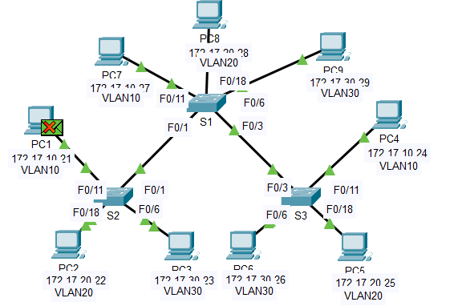
The ping fails because PC1 is VLAN 10 and PC6 is VLAN 30, so there are two different VLANs. PC1 cannot communicate with PC6.

Look at the Simulation Panel, where did S3 send the packet after receiving it?

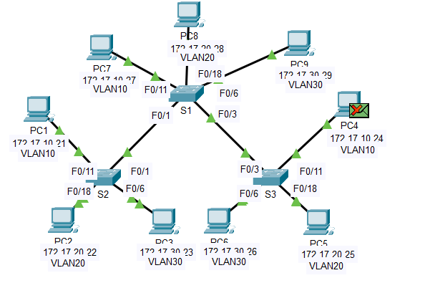
S3 will send the packet to PC4 because PC4 and PC1 are the same VLAN (VLAN 10).

In normal operation, when a switch receives a broadcast frame on one of its ports, it forwards the frame out all other ports. Notice that S2 only sends the ARP request out F0/1 to S1. Also notice that S3 only sends the ARP request out F0/11 to PC4. PC1 and PC4 both belong to VLAN 10. PC6 belongs to VLAN 30. Because broadcast traffic is contained within the VLAN, PC6 never receives the ARP request from PC1. Because PC4 is not the destination, it discards the ARP request. The ping from PC1 fails because PC1 never receives an ARP reply.

Step 2: Ping from PC1 to PC4.
- Click the New button under the Scenario 0 dropdown tab. Now click on the Add Simple PDU icon on the right side of Packet Tracer and ping from PC1 to PC4.

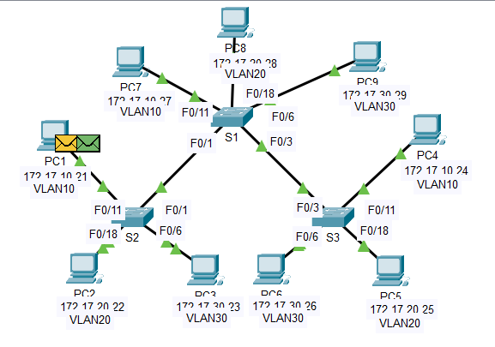

- Click the Capture/Forward button to step through the process. Observe the ARP requests as they traverse the network. When the Buffer Full window appears, click the View Previous Events button.
Were the pings successful? Explain.

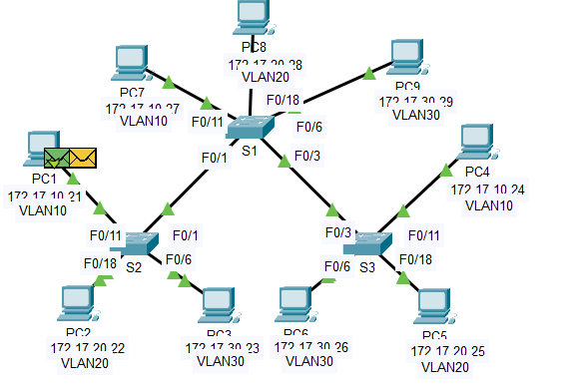
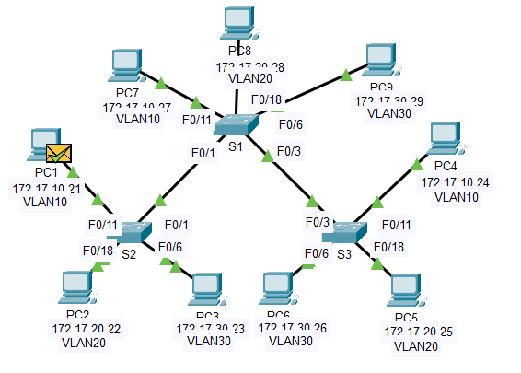
Ping is successful because PC1 and PC4 are in the same VLAN (VLAN 10). The path of the ARP request is the same, and PC4 is also the destination, so it can reply to the ARP request.

- Examine the Simulation Panel.
When the packet reaches S1, why does it also forward the packet to PC7?

Because PC7 also belongs to VLAN 10 like PC1 and PC4. The switch will forward to all devices in its ports that belong to VLAN 10.

Part 2: Observe Broadcast Traffic without VLANs

Step 1: Clear the configurations on all three switches and delete the VLAN database.
- Return to Realtime mode.
- Delete the startup configuration on all 3 switches.
What command is used to delete the startup configuration of the switches?

S1
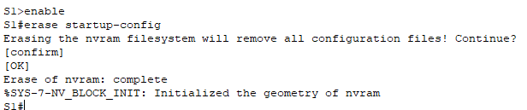
S2
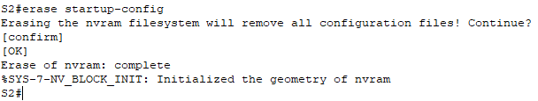
S3
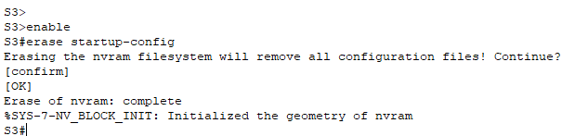

S1#erase startup-config
S2#erase startup-config
S3#erase startup-config
Where is the VLAN file stored in the switches?

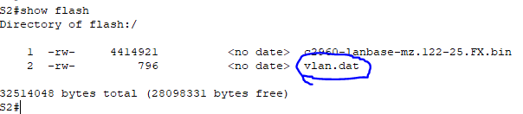
vlan.dat

- Delete the VLAN file on all 3 switches.
What command deletes the VLAN file stored in the switches?

S1
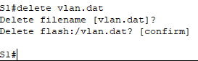

S2
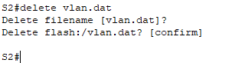

S3
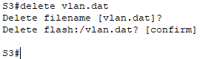

delete vlan.dat

Step 2: Reload the switches.
Use the reload command in privileged EXEC mode to reset all the switches. Wait for the entire link to turn green. To accelerate this process, click Fast Forward Time located in the bottom yellow toolbar.

S1

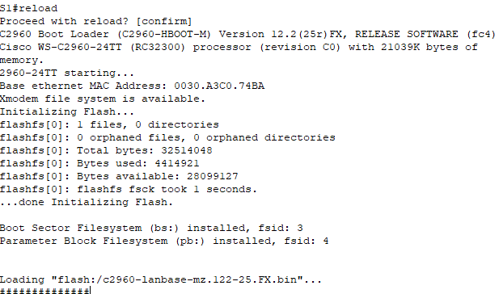
S2

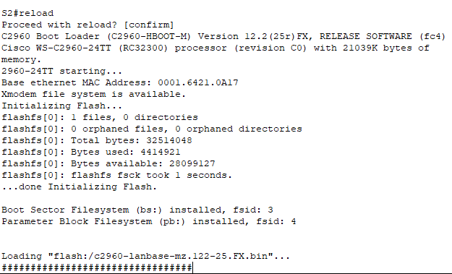
S3
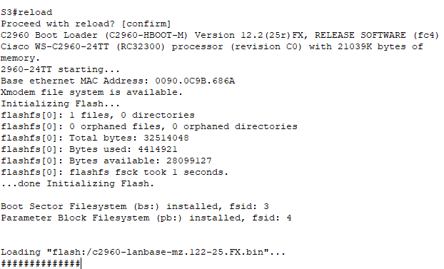

Step 3: Click Capture/Forward to send ARP requests and pings.
- After the switches reload and the link lights return to green, the network is ready to forward your ARP and ping traffic.
- Select Scenario 0 from the drop-down tab to return to Scenario 0.
- From Simulation mode, click the Capture/Forward button to step through the process. Notice that the switches now forward the ARP requests out all ports, except the port on which the ARP request was received. This default action of switches is why VLANs can improve network performance. Broadcast traffic is contained within each VLAN. When the Buffer Full window appears, click the View Previous Events button.

Reflection Questions
- If a PC in VLAN 10 sends a broadcast message, which devices receive it?

All devices which are on VLAN 10

- If a PC in VLAN 20 sends a broadcast message, which devices receive it?

All devices which are on VLAN 20

- If a PC in VLAN 30 sends a broadcast message, which devices receive it?

All devices which are on VLAN 30

- What happens to a frame sent from a PC in VLAN 10 to a PC in VLAN 30?

It was dropped.

- In terms of ports, what are the collision domains on the switch?

Each port is a separate collision domain.
For example, if there are 26 ports, then so are 26 collision domains.

- In terms of ports, what are the broadcast domains on the switch?

They are divided by the number of VLANs in the switch.
For example, if there are 3 VLANs (VLAN 10, 20, 30) then 3 broadcast domains.

